|  |  |  |  |  |  |  |  |  |
| --- | --- | --- | --- | --- | --- | --- | --- | --- |
| Name of Event……………. | | | | | | | | |
|  | | | | | | | | |
| Category of Event: | Cultural |  | Civic/Community |  | Educational |  | Entertainment |  |
| Date of Event ……………………………………… Total Number of banners …………….  Date banners to be installed: From To | | | | | | | | |
| Contact Name and Telephone No. | | | | | | | | |

**Location of banners to be erected:** *(Copy of banner proof must be attached)*

|  |  |  |  |  |  |
| --- | --- | --- | --- | --- | --- |
| **BYRON BAY** | | | **BANGALOW** | | |
|  | |  | | |
| **Ewingsdale Road at 50km Zone** | | | **Byron Street near Ballina Road** | | |
|  | |  | | |
|  | Facing East Bound Traffic |  | | Facing East Bound Traffic |
|  |  |  | |  |
|  | Facing West Bound Traffic |  | | Facing West Bound Traffic |
|  |  |  | |  |
| **Bangalow Road Near Byron Bay High School** | | | **Lismore Road near Robinson Street** | | |
|  | |  | | |
|  | Facing South Bound Traffic |  | | Facing East Bound Traffic |
|  | |  | | |
| **BRUNSWICK HEADS** | | | **MULLUMBIMBY** | | |
|  | |  | | |
| **Tweed Street near Pilgrim Park** | | | **Argyle Street near Manns Road** | | |
|  | |  | | |
|  | Facing South Bound Traffic |  | Facing East Bound Traffic | |
|  |  |  | | |
|  | Facing North Bound Traffic |  | | Facing West Bound Traffic |
|  | |  | |  |
| **Tweed Street near Fisherman’s Co-op** | | |  | | |
|  | |  | | |
|  | Facing South Bound Traffic |  | |  |

I understand the conditions for installing street banners as listed on council’s webpage.

Signed Date

**Costs**

|  |  |  |  |
| --- | --- | --- | --- |
| **Community (non-profit)** Rates ($)** | | **Commercial Rate ($)** | |
| 1st Pole/New Location | 161.00 | 1st Pole/New Location | 245.00 |
| Additional Poles same location (each) | 63.00 | Additional Poles same location each | 93.00 |

***\*\*Applicants applying as non-profit making bodies must attach a copy of the association’s Certificate of Incorporation.***

Council accepts payments by cash, cheque, money order, eftpos or credit card (Visa and Master only) at Council’s administration offices. All cheques are to made payable to Byron Shire Council. Should you wish to mail your application package to Council and wish to use the credit card facility, please download An Authority to Charge Credit Card form which can be found at [www.byron.nsw.gov.au/forms](http://www.byron.nsw.gov.au/forms) or alternatively enclose a cheque or money order.

Any enquiries may be directed to Council’s Works Depot on 6685 9300.

|  |  |
| --- | --- |
| Office Use Only | Customer Action Request (CRM) No: |
| Payment of fee to be paid for each banner to 1725.9.596 |
| Receipt No:______________________ Date Paid: _____________  Amount Paid: $__________________ |

**Specifications for Street Banners**

The banners are an Olympic style or vertical banner and have standard specifications.

* maximum length of street banner to be 2000mm including seam at top

**Vinyl banners**

* maximum width of street banner to be 900mm
* material to be heavy duty, reinforced PVC or equivalent
* double sided graphics/text
* double stitched seam across the top (a total width of 900mm) with bottom having 5 x 15mm eyelets **(50mm from the bottom of the banner)** so that the banner can be slipped onto the top arms and laced to the pole at the bottom

# Street Banner Pole Vinyl Street Banner

Folded double stitched seam

of 200mm

Width 900mm

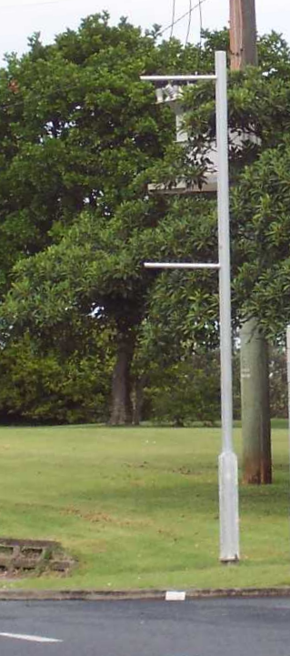

Length 2000mm

Total distance 2000mm

5 x 15mm eyelet holes

**50mm from bottom of banner**

Threaded rope (supplied by BSC)

## Installation Information

* Street banner(s) are to be delivered to Council’s Depot, 10 Bayshore Drive Byron Bay, between 7.00am and 4.00pm at least 2 working days prior to installation.
* Street banner(s) to be collected from Council’s Bayshore Drive Depot within **24 hours** of the completion of the event/agreed completion date.  Council will not store banners.