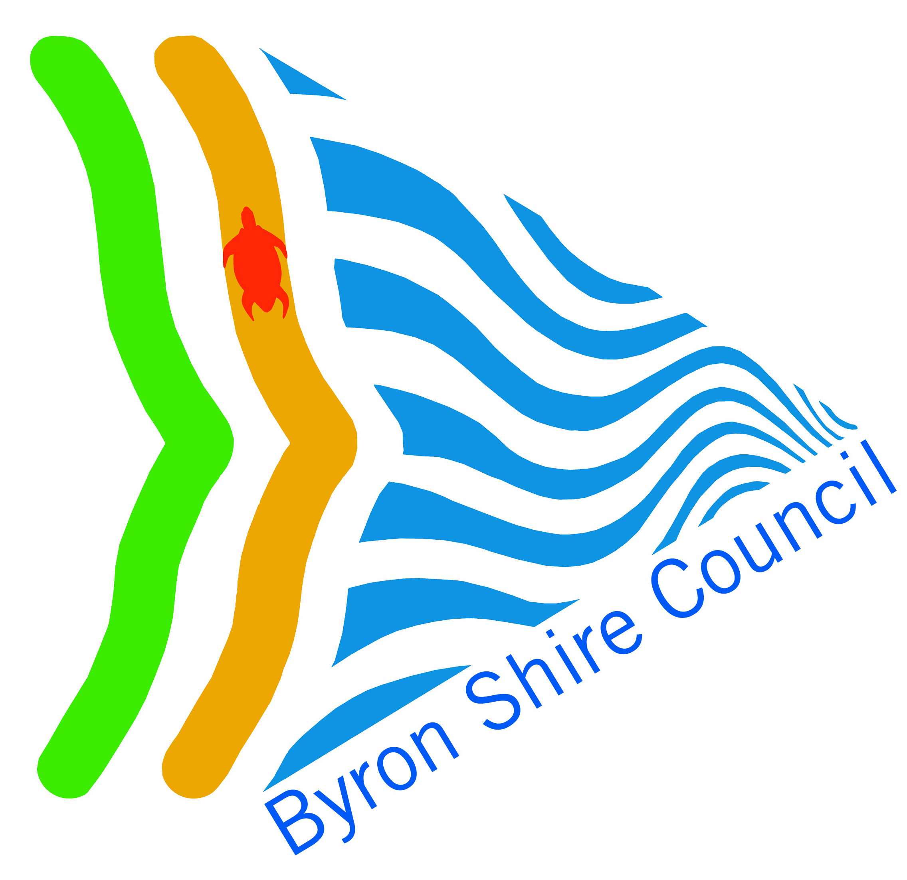 |  | Tax Invoice/ RECEIPT 2017/01
Venue/ Hall name  Byron Shire Council  P.O. Box 219, Mullumbimby NSW 2482.  ABN 14 472 131 473 |  |  |  |  | Venue details here  PO Box 219  Mullumbimby NSW 2482.  Ph. (02) 66267000  Fax (02) 66843018
Date: 15 August 2016

To: Attention: Person
Address

Qty | Description of Supply |  |  | Price |  | Total
1 | Hire of Hall Byron Bay as per Hire Agreement 1 July to 31 December 2016 |  |  | $900 |  | $900
 | 3 hours per week for 20 weeks (60 hours)
 | Bank account details:
Bank:
BSB:
Acc:
 |  |  | TOTAL AMOUNT PAYABLE |  |  | $900.00
 |  |  | Total includes GST of |  |  | $90.00
 |  |  | Total PAID |  |  | $0.00
Electronic Funds Transfer preferred
Cheques payable to ‘Venue/ Hall’
Post cheque and remittance advice to VENUE DETAILS

